Diabetes Dashboard – MeriSKILL Project 2

Date : 11th March 2024

**Tools Used:**

* Power BI
* Excel

**Project Overview:**

To understand the data and gain more insights on which users are more likely to have diabetes based on various factors.

**Data Source:**

* Kaggle Dataset
* Provided by MeriSKILL

**Features:**

* Pregnancies: Number of times pregnant
* Glucose: Plasma glucose concentration a 2 hours in an oral glucose tolerance test
* BloodPressure: Diastolic blood pressure (mm Hg) 90/60 (diastolic) to 120/80(systolic) mmHG
* SkinThickness: Triceps skin fold thickness (mm) 🡪 23.6 ± 7.5 mm vs 14.3 ± 6.8 mm
* Insulin: 2- Hour serum insulin (mu U/ml)
* BMI: Body mass index (weight in kg/(height in m)^2) - If your BMI is less than 18.5, it falls within the underweight range. If your BMI is 18.5 to 24.9, it falls within the Healthy Weight range. If your BMI is 25.0 to 29.9, it falls within the overweight range.

* DiabetesPedigreeFunction: Diabetes pedigree function(calculates diabetes likelihood depending on the subject's age and his/her diabetic family history)
* Age: Age (years)
* Outcome: Class variable (0 or 1)- Diabetic | Non-Diabetic

**Ranges Understanding -**

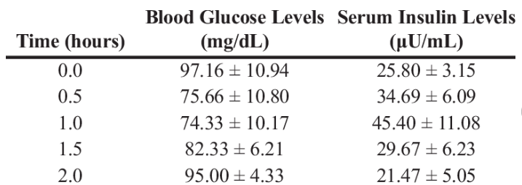

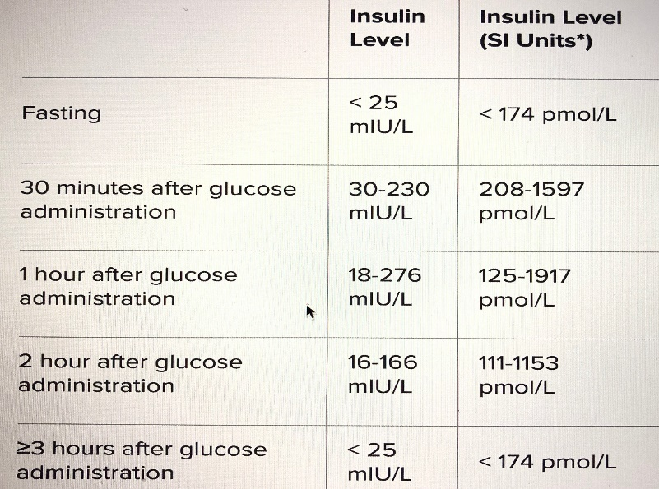

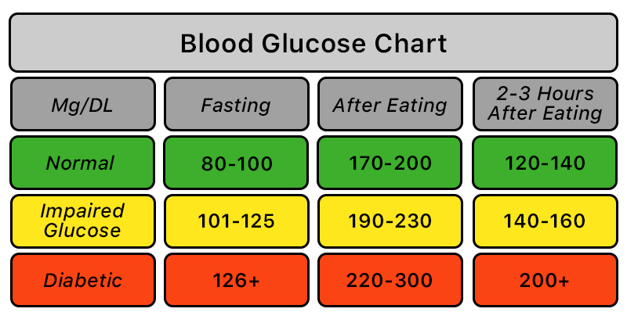

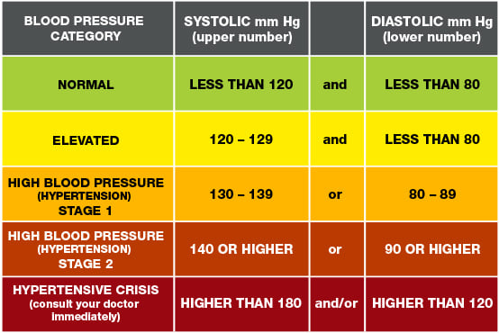

**Features Transformation:**

1. **Pregnancies- group 0 – 17 🡪 < 5, >=5 & <=10, >10 & <= 15, > 15**
2. **Glucose – 2 hour after -> categorized as < 140 normal and >=140 to 199 is impaired glucose, 200+ diabetic**
3. **BP – categorized as**

**Normal < 80, Hypertension_stage1 between 80 to 89, hypertension_stage2 between 90 to 120, Hypertensive crisis > 120**

1. **Skin Thickness- as data is of females, consider females fold thikness- 16 to 31 normal**

Women have much higher TSF thickness than men (23.6 ± 7.5 mm vs 14.3 ± 6.8 mm). **–According to national institute of health.**

1. **Insulin – 16 to 26 – normal level**
2. **BMI – categorized as**

**Healthy >= 18.5 & <=24.9, underweight < 18.5, overweight >=25 & <30, obese >30**

**Diabetes pedigree function -** 0.07 to 0.853

0.853 to 1.636

1.636 to 2.42

🡪 there is no particular normal range for it. But as this func value increases it is likelihood of calculating diabetes based on a DPF tool.

1. **Age- age group with 10 bins e.g 20 to 29, 30 to 39 etc.**
2. **Outcome- 0- Non- diabetic, 1- Diabetic**

Dashboard:

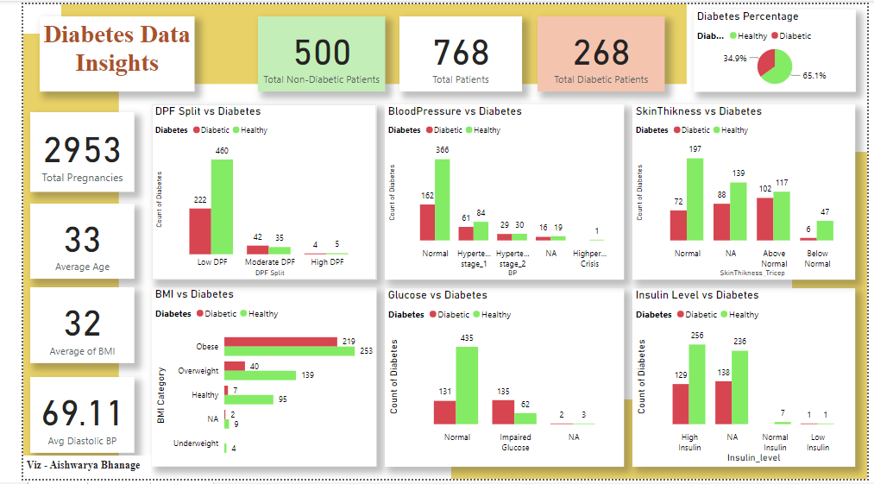

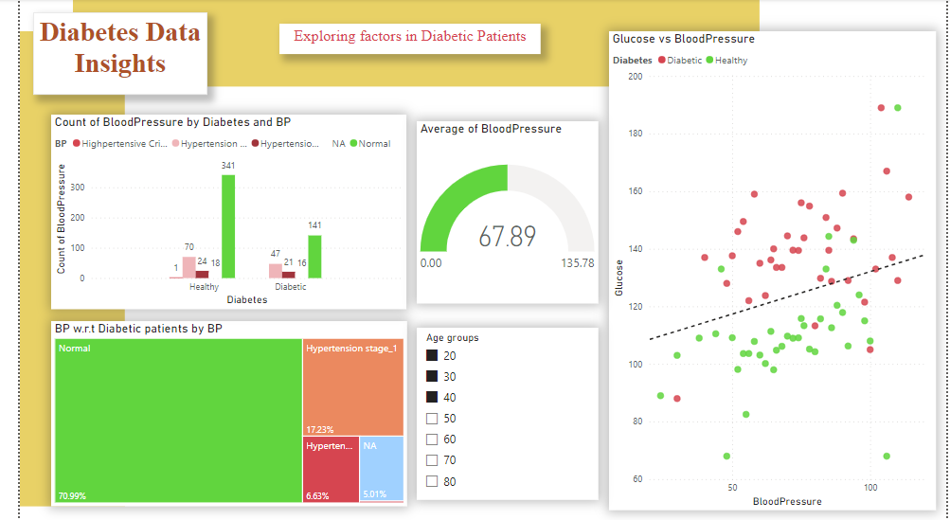

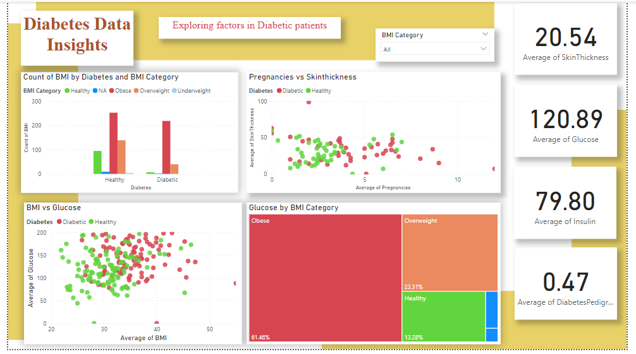

**Data Cleaning and Transformation:** During data cleaning, we addressed missing values, such as replacing zero values for insulin with NA. Additionally, we transformed numerical features into categorical ones based on relevant health ranges, ensuring data accuracy and relevance

**Insights:**

1. **Glucose and Insulin Significance:**

* People with higher glucose and insulin levels tend to have a higher likelihood of being diabetic.
* Higher glucose levels are strongly associated with diabetes.
* Presence of insulin is crucial. Zero values replaced with NA due to improbability of such case.

1. **Obesity and Diabetes Connection:**

* A significant number of diabetic patients fall into the obese or overweight category. This highlights the relationship between obesity and diabetes risk.

1. **Age and Pregnancy Factors:**

* Age group 22 to 40 and the number of pregnancies between 4 to 9, along with skin thickness between 17 to 51, are associated with a higher incidence of diabetes.

1. **Impaired Glucose and Diabetes:**

* Individuals with impaired glucose tolerance have a significantly higher risk of developing type 2 diabetes compared to those with normal blood sugar levels.
* This shows the importance of early detection and intervention for pre-diabetic conditions.

1. **Blood Pressure Insights:**

* Although blood pressure (BP) doesn't show a strong correlation with diabetes in the dataset, maintaining healthy blood pressure levels is still crucial for overall health.

These insights provide valuable information for understanding the relationships between various factors and diabetes risk in the dataset. They emphasize the importance of proactive measures for diabetes prevention, including lifestyle modifications, regular screenings, and maintaining overall health.